User Acceptance Testing (UAT) Template
Date | 30 September 2026
Team ID | SWTID-2026-6284
Project Name | AI WEATHER WISE API
Maximum Marks

- Project overview
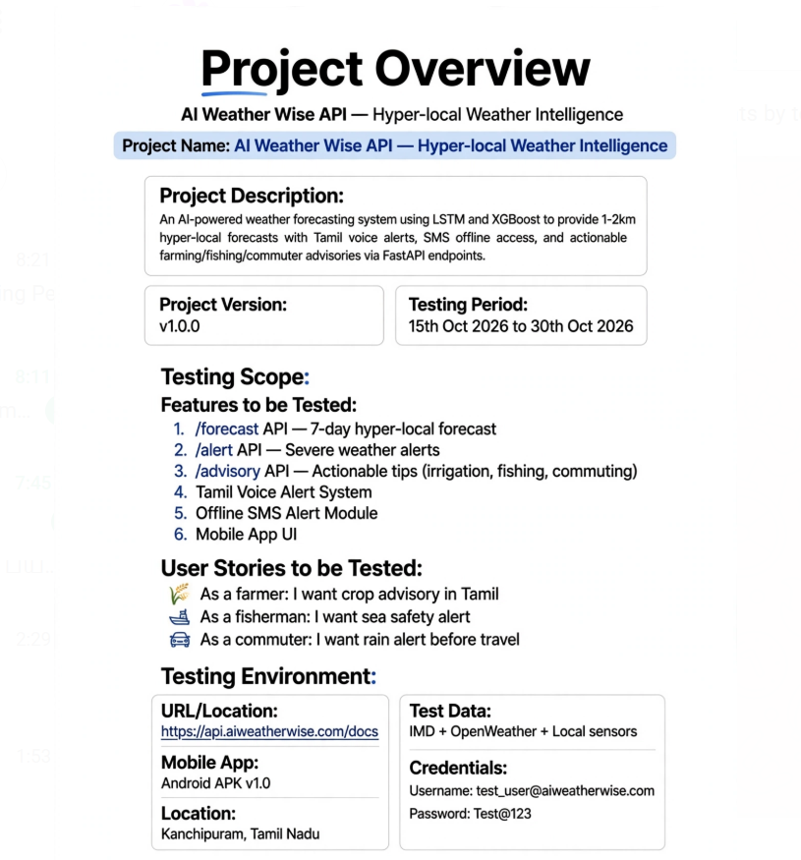

- TEST CASES

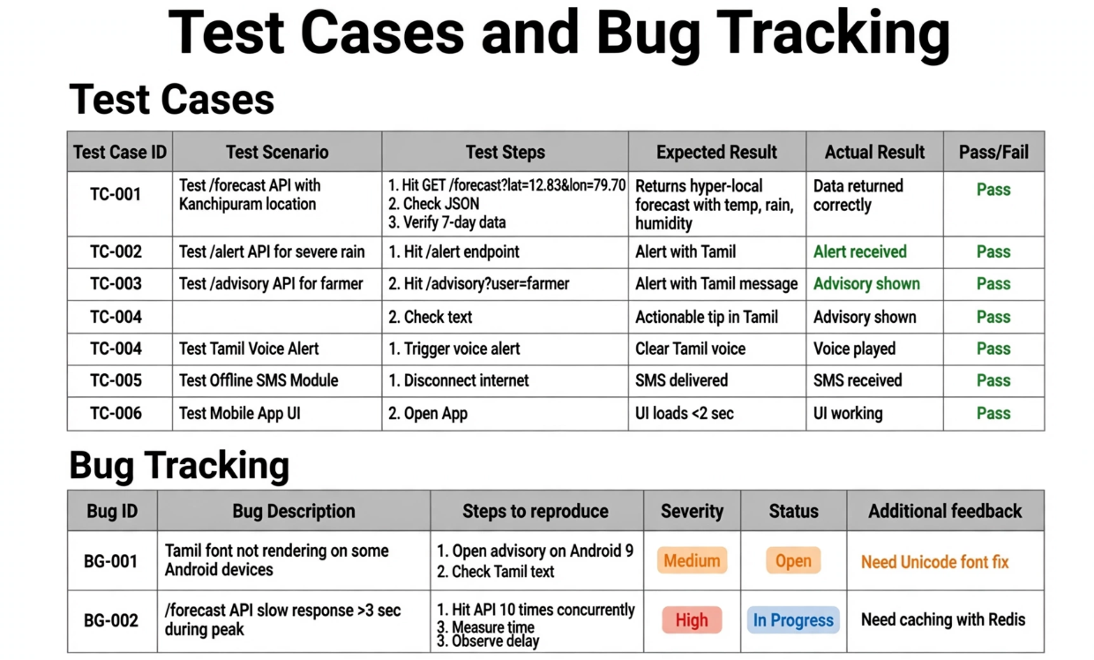

- SING OFF
